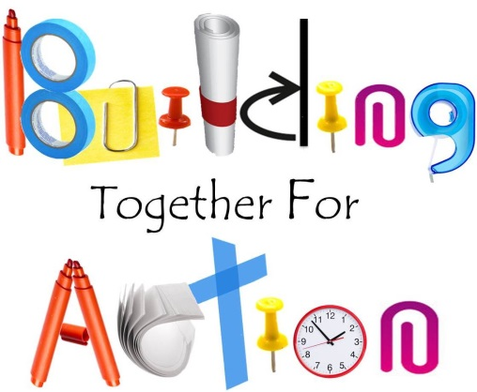

2015 Annual Gathering
Building Together for Action

Session Proposal

To submit completed forms, go to www.top-network.org/2015-gathering-solicitation, scroll to the bottom of the page, click on the pushpin and follow the steps.
Proposed Session Name:
Targeting which theme? |  |  | Building the Foundation |  |  |  | Creating our Living Space |  |  |  |  | Living in the House of ToP |  |  |  |  | Using Our Tools
Rational Aim:
Experiential Aim:
How do you propose to approach the topic?
Number of participants: |  |  |  | Min: |  |  |  | Max: |  |  |  |  | Session length:
Supplies and/or
Equipment this session will need
What of this can you supply?
Submitted by: |  |  |  |  |  |  |  |  |  |  |  | Phone Number:
Email:
Anything else you’d like us to know/ consider? (add pages as needed)

To submit, go to www.top-network.org/2015-gathering-solicitation, scroll down and click on the pushpin.

